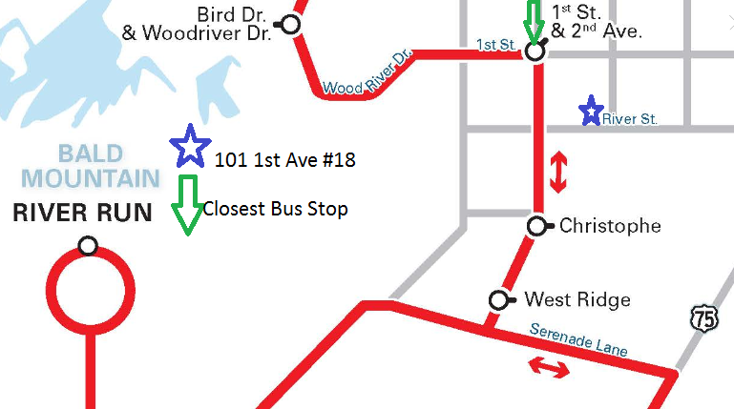
AM schedule

PM schedule
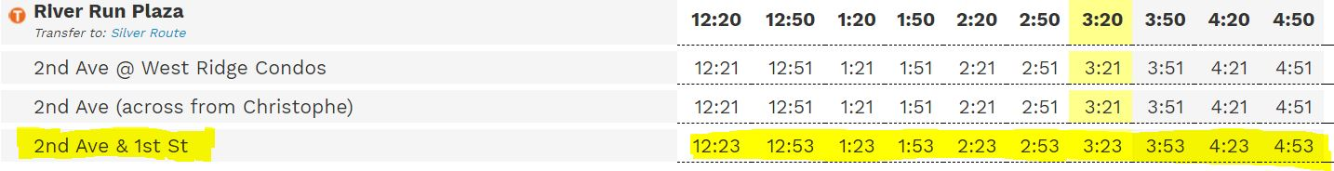
This bus schedule and a more complete schedule are always available online. For quick access please use the link below.
http://www.mountainrides.org/ketchumsv-area-red-route

